A

Project Report On

## Fitness Center

Submitted By

### Ashish 190822231054

**Shrey 19082231036**

### B.Sc. (Information Technology) Semester-VI

Guided By

### Ms. Dhara Darji

DCS Final Logo

Submitted to

### Department of Computer Science Ganpat University, Ganpat Vidyanagar-384012

**April - May 2022**

|  |  |
| --- | --- |
| DCS Final Logo | **Department of Computer Science Ganpat University,**  **Ganpat Vidyanagar-384012** |

## C E R T I F I C A T E

**Date: 05/05/2022**

**T O W H O M S O E V E R I T M A Y C O N C E R N**

This is to certify that the following students of Bachelor of Science in Information Technology Semester-VI have completed their full time project work titled “**Fitness Center**” satisfactorily.

|  |  |
| --- | --- |
| **Name** | **Exam No** |
| **Ashish Soni** | **19082231054** |
| **Shrey Patel** | **19082231036** |

|  |  |  |
| --- | --- | --- |
| **Internal Guide** | **Project Co-ordinator** | **Principal/HOD** |
| Ms. Dhara Darji | Ms. Dhara Darji | Dr. Satyen Parikh |

# ACKNOWLEDGEMENT

We express our heart gratitude to number of people who extended their full support and cooperation in developing this project First, We Would like take this opportunity to thank our college” **Ganpat University**” for giving us this opportunity and a platform for discovering and developing our potential, this king of experience that we have received while making this project report is so immense the narrating that in few worlds is difficult.

No task can be accomplished without proper support, guidance and appraisal. We are highly thankful to many people who contributed either directly or indirectly in our training and provided their invaluable co-operation to us in completion of this project.

After that our heartiest thank is our internal guide as well as respected faculty “**Ms. Dhara Darji**” for entrusting upon us the responsible and acting as ray of light in darkness. We find our self-short of world to describe our feeling for the role she played of friend, a philosopher and guide, whenever we were in need.

Last but not the least we are also thankful to our friends, project partners, colleagues and parents for their support and understanding they provided us during the project work. We are also very much thankful to all who directly or indirectly helped us.

Prepared by:- Ashish Soni Shrey Patel

# ABSTRACT

* The project report has been made to make easy of understanding of the web application developed for project fulfillment in **B.Sc. (IT) SEM- VI**, where project report contains the documentation of project and project presentation.
* Find Products & Merchants related to fitness will be provide users to build their body and make them health conscious.
* User can view different type of search option like products, categories, merchants. User can contact us, using sending email address and phone number.
* User can buy product with different types, like dumbbell with 10 kg, 20 kg etc. and can pay via cash on delivery and via UPI.
* User can see their booked product details and booking details.

# INDEX

|  |  |  |
| --- | --- | --- |
| **Sr. No** | **Title** | **Page No** |
| 1 | Project Profile   * 1. Project Title   2. Objective | 1 |
| 2 | Requirement specification 2.1About Existing System  2.2Need for new system/ Features of the new system | 2 |
| 3 | Minimum Hardware & Software Requirement   * 1. Client Side Hardware / Software Requirement   2. Server Side Hardware / Software Requirement | 3 |
| 4 | Function Specification 4.1User of the System  4.2Modules of the System | 4 |
| 5 | System Flow Chart | 5 |
| 6 | ER Diagram | 6 |
| 7 | Data Flow Diagram [DFD] | 7 |
| 8 | Data Dictionary | 10 |
| 9 | Process Description (Module wise) | 16 |
| 10 | Input/ Output Design (Screen Layouts with title and brief description on each screen shot) | 19 |
| 11 | Testing (Design test cases of validations in tabular  form) | 45 |
| 12 | Future Enhancement | 51 |
| 13 | Conclusion | 52 |
| 14 | Bibliography / References | 53 |

1. **PROJECT PROFILE**

**Fitness Center**

|  |  |
| --- | --- |
| **Project Title:** | **Fitness Center (E-Commerce Website)** |
| Developed for:- | Department of Computer Science |
| Development Tool:- | Sublime Text 3 |
| Front end Tool:- | Html5,Css3,Javascript,Jquery |
| Back end Tool:- | PHP(8.0),MYSQL(8.0) |
| Internal guide:- | Ms. Dhara Darji |
| Prepared by:- | Ashish Soni & Shrey Patel |

**Objective: -** Fitness Center is used to give online Selling Equipment, and other products related to fitness.

P a g e 1 | 53

**Fitness Center**

# REQUIREMENT SPECIFICATION

#### About Existing System: -

* + There is no guarantee of good quality equipment in existing system.
  + There is no guarantee of good durability of equipment's in existing system.
  + There is no guarantee of safe shipping without damaging equipment in existing system.
  + There is no guarantee of good discount on equipment’s in existing system.

#### Need for New System:-

* + There is a facility to buy online gym equipment's.
  + User cannot buy any product without registration and login.
  + User cannot log in without verification code at first time.
  + User can also get an offers in festivals.
  + There will be no false delivery if there it is use can complaint it and resolve in 24 hour.
  + After order successfully user can get the detail in mail.

P a g e 2 | 53

**Fitness Center**

# MINIMUM HARDWARE & SOFTWARE REQUIREMENT.

#### Client side hardware:-

|  |  |  |
| --- | --- | --- |
| **Processor** | **:** | Corei3 or Higher |
| **RAM** | : | 4 GB |
| **Hard disk** | : | 1 TB |

* + - **Software Requirement:-**

|  |  |  |
| --- | --- | --- |
| **Operating System** | **:** | Windows 10,9,8 or Higher |
| **Browser** | : | Internet Explorer 8 or later, Mozilla Firefox 28 or later, Google Chrome 34 or later, Opera 18, Any Browser. |

#### Server side Hardware:-

|  |  |  |
| --- | --- | --- |
| **Processor** | **:** | Corei3 or Higher |
| **RAM** | : | 4 GB |
| **Hard disk** | : | 1 TB |

* + - **Software Requirement:-**

|  |  |  |
| --- | --- | --- |
| **Front End** | **:** | Sublime 3 with php server extension. |
| **Back End** | **:** | SQL Server and apache server |
| **Operating System** | **:** | Windows Server 2008 or Higher |

P a g e 3 | 53

**Fitness Center**

# FUNCTION SPECIFICATION

#### a. There are main Two Users of this system.

* Admin :-
  + Login
  + Manage Users
  + Manage Categories
  + Manage Product
  + Manage Order
  + Manage Contact us
  + Manage Transection
* Users :-
  + Login
  + See Product
  + Add to cart Product
  + Buy Product
  + Make Payment
  + Manage Profile
  + Give Feedback

P a g e 4 | 53

# SYSTEM FLOW CHART

**Fitness Center**

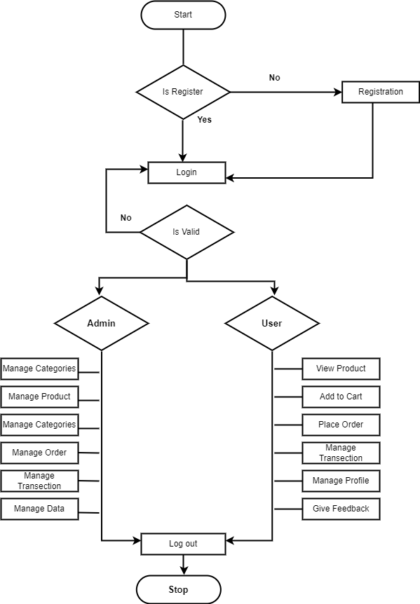

P a g e 5 | 53

**Fitness Center**

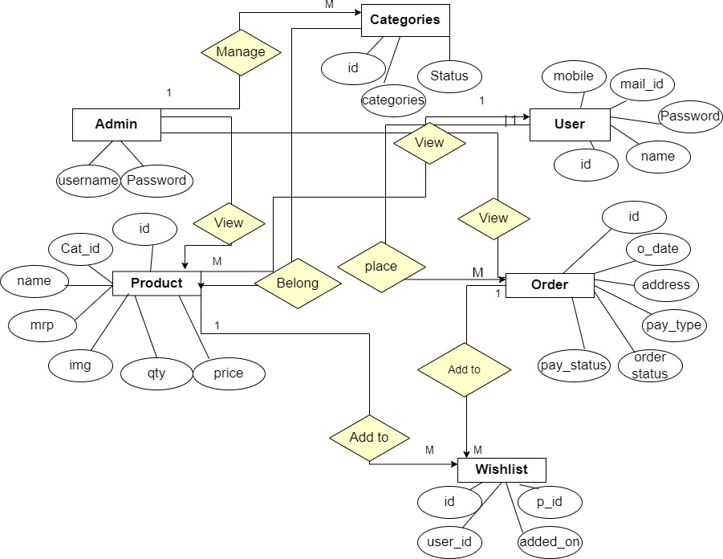

1. **ENTITY-RELATIONSHIP (ER) DIAGRAM :-**

P a g e 6 | 53

**Fitness Center**

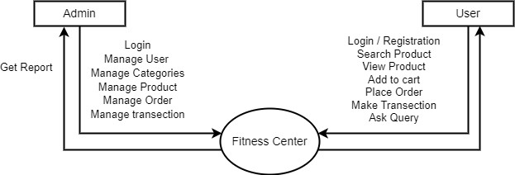

### DATA FLOW DIAGRAM (DFD):-

P a g e 7 | 53

**Fitness Center**

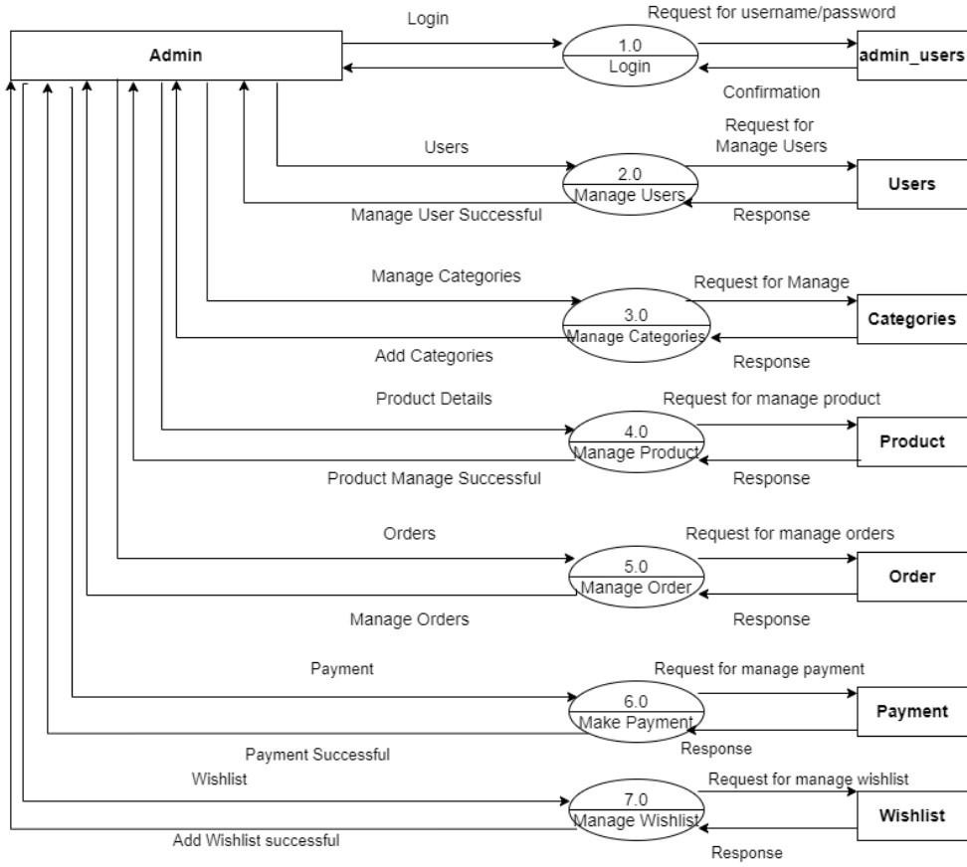

* 1. **First Level Data Flow Diagram (Admin):-**

P a g e 8 | 53

**Fitness Center**

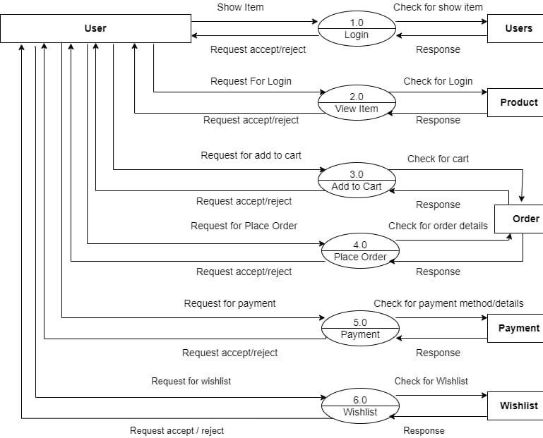

#### First Level of Data Flow Diagram (User):-

P a g e 9 | 53

**Fitness Center**

# DATA DICTIONARY:-

1. Table Name: **-** admin_users

Primary Key: **-** id

Description: - Information about the admin

|  |  |  |  |  |
| --- | --- | --- | --- | --- |
| **Fieldname** | **Data types** | **Size** | **Constraint** | **Description** |
| id | int | 11 | primary key | to store id |
| username | varchar | 12 | not null | to store username |
| password | varchar | 8 | not null | to store password |

1. Table Name**: -** Users

Primary Key: - id

Description**: -**Information about the user.

|  |  |  |  |  |
| --- | --- | --- | --- | --- |
| **Fieldname** | **Data types** | **Size** | **Constraint** | **Description** |
| id | int | 11 | primary key | to store id |
| name | varchar | 255 | not null | to store username |
| password | varchar | 50 | not null | to store password |
| email | varchar | 50 | not null | to store email |
| mobile | varchar | 10 | not null | to store mobile |
| added_on | Date time |  | not null | user enter date |

P a g e 10 | 53

**Fitness Center**

1. Table Name: - Categories Primary Key: - id

Description**: -**Information about Categories Table

|  |  |  |  |  |
| --- | --- | --- | --- | --- |
| **Fieldname** | **Data types** | **Size** | **Constraint** | **Description** |
| id | int | 11 | primary key | to store categories id |
| categories | varchar | 255 | not null | to store categories |
| status | tinyint | 4 | not null | to store categories status |

P a g e 11 | 53

**Fitness Center**

1. Table Name: - Product Primary Key: - id

Description: **-**Information about product table

|  |  |  |  |  |
| --- | --- | --- | --- | --- |
| **Fieldname** | **Type** | **Size** | **Constrai nt** | **Description** |
| id | int | 11 | primary key | to store id |
| categories_id | int | 11 | not null | to store categories id |
| name | varchar | 255 | not null | to store name |
| mrp | float |  | not null | to store mrp |
| price | float |  | not null | to store price |
| qty | int | 10 | not null | to store product qty |
| image | varchar | 255 | not null | to store product image |
| short_desc | varchar | 2000 | not null | to store product short desc |
| desc | text |  | not null | to store product desc |
| best_seller | int | 11 | not null | to store best seller |
| meta_title | varchar | 2000 | not null | to store meta title |
| meta_desc | varchar | 2000 | not null | to store meta desc |
| meta_keywor d | varhcar | 2000 | not null | to store meta keyword |
| status | tinyint | 4 | not null | to store product status |

P a g e 12 | 53

**Fitness Center**

1. Table Name: - Order

Primary Key: - id

Description: **-**Information about Order Table

|  |  |  |  |  |
| --- | --- | --- | --- | --- |
| **Fieldname** | **Type** | **Size** | **Constraint** | **Description** |
| id | int | 11 | primary key | To store id. |
| user_id | int | 11 | not null | To store user id. |
| address | varchar | 250 | not null | To store address. |
| city | varchar | 50 | not null | To store city. |
| Pin code | int | 6 | not null | To store pin code. |
| payment_type | varchar | 20 | not null | To store payment method. |
| Total_price | float |  | not null | Total amount. |
| payment_status | varchar | 20 | not null | To store payment status. |
| order_status | int | 11 | not null | To store order status. |
| txnid | varchar | 20 | not null | To store transection id. |
| mihpayid | varchar | 20 | not null | To store pay id. |
| pay_status | varchar | 20 | not null | To store pay status. |
| added_on | datetime |  | not null | To store time date when user Place order. |

P a g e 13 | 53

**Fitness Center**

1. Table Name: - Order_detail

Primary Key: - id

Description: -Information about order details

|  |  |  |  |  |
| --- | --- | --- | --- | --- |
| **Fieldname** | **Type** | **Size** | **Constraint** | **Description** |
| id | int | 11 | primary key | to store id |
| order_id | Int | 11 | not null | to store order id |
| product_id | Int | 11 | not null | to store product id |
| qty | int | 10 | not null | to store qty |
| price | float |  | not null | to store price |

1. Table Name: - contact_us

Primary Key: - id

Description: -Information about contact_us

|  |  |  |  |  |
| --- | --- | --- | --- | --- |
| **Fieldname** | **Data types** | **Size** | **Constraint** | **Description** |
| id | int | 11 | primary key | to store id |
| name | varchar | 255 | not null | to store name |
| email | varchar | 75 | not null | to store email |
| mobile | varchar | 10 | not null | to store mobile |
| comment | text |  | not null | to store comment |
| added_on | datetime |  | not null | to store added_on |

P a g e 14 | 53

**Fitness Center**

1. Table Name: **-** wishlist

Primary Key: - id

Description: -Information about wishlist table

|  |  |  |  |  |
| --- | --- | --- | --- | --- |
| **Fieldname** | **Type** | **Size** | **Constraint** | **Description** |
| id | int | 11 | primary key | to store id |
| user_id | int | 11 | not null | to store user id |
| product_id | int | 11 | not null | to store product id |
| added_on | timedate |  | not null | to store timedate when user add wishlist |

P a g e 15 | 53

**Fitness Center**

# BRIEF DESCRIPTION PROCESS:-

The Fitness Center is a recreational, and social facility geared towards exercise, sports, and other physical activities.

**Fitness Center Modules:-**

* + Admin Modules
  + User Module
* **Common process for all modules**
  + Registration Process
  + Login Process
  + Search Process
* **Registration Process:-**

In this process admin and user must have to registration on that site if it is registered then it will directly go for authentication checking, until admin don’t approve that, user can’t be login and further task.

* **Login Process:-**

In this process, if user is registered the go for checking valid user. It will enter username, password. It can change the password of created user and also view and edit own profile.

* **Search Process:-**

In this process, user and visitors will be searched based on required like from Dumbbells, treadmills, benches, plates, powder etc.

P a g e 16 | 53

**Fitness Center**

* **Admin Module:-**
  + Register User
  + Dashboard
  + Categories
  + Product
  + Manage Orders
  + Manage Users
  + Contact us
* **Register user: -** Admin can manage the register user like view, update, delete.
* **Dashboard: -** Admin can see all details like a categories master, product master, order master, user master, contact us.
* **Categories: -** Admin can manage the equipment's categories (add, view, delete, update).
* **Product: -** Admin can manage the product like add, delete, update, activate & deactivate**.**
* **Manage Orders: -** Admin can view the order details and change the order according to current status.
* **Manage Users: -** Admin can view the all user of website.
* **Contact us: -** Admin can view the response from the user and change the status.

P a g e 17 | 53

**Fitness Center**

### User Module:-

* + Login
  + Search
  + View Product
  + Add to cart
  + Buy now
  + Transection
  + Feedback
* Login: - User cannot buy any product without login process.
* Search: - User can search the equipment's in the search bar for view the new equipment's.
* View product: - User can view any product without registration.
* Add to cart: - User can add the equipment's which she/he want buy and also delete the already added items.
* Buy now: - User can buy any product if he/she want to make order.
* Transection: - User can buy any product do the make transection and take rewards.
* Feedback: - User can share the experience regarding their ordered product.

P a g e 18 | 53

**Fitness Center**

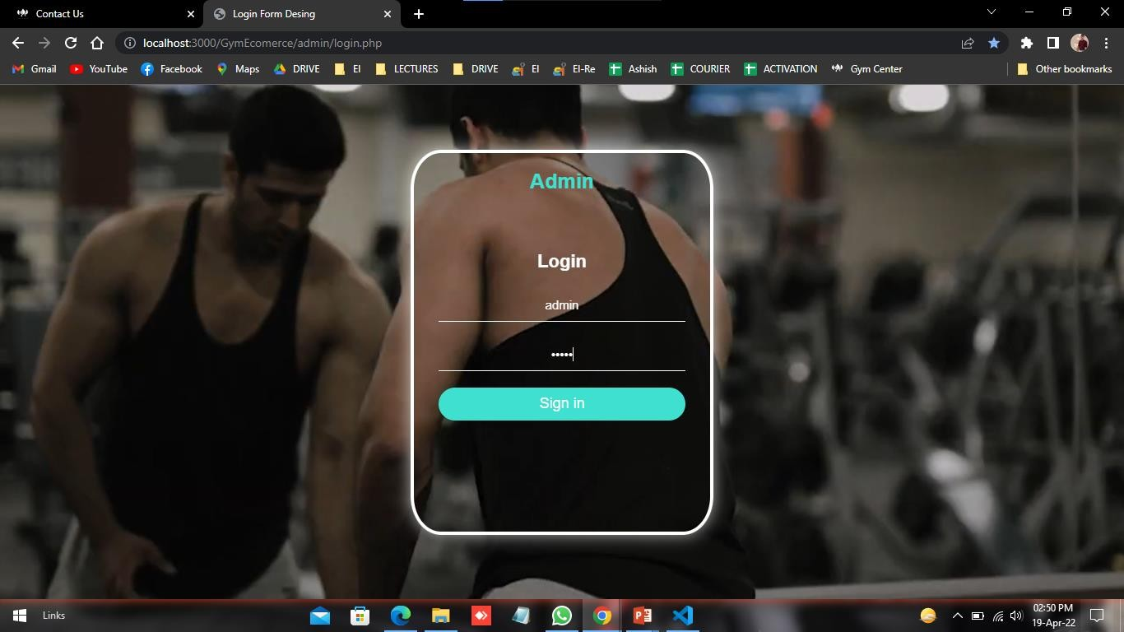

# INPUT/OUTPUT DESIGN:-

## Admin panel

**Admin Login Page:-**This is Log in page for admin where admin can login with their id and password.

P a g e 19 | 53

**Fitness Center**

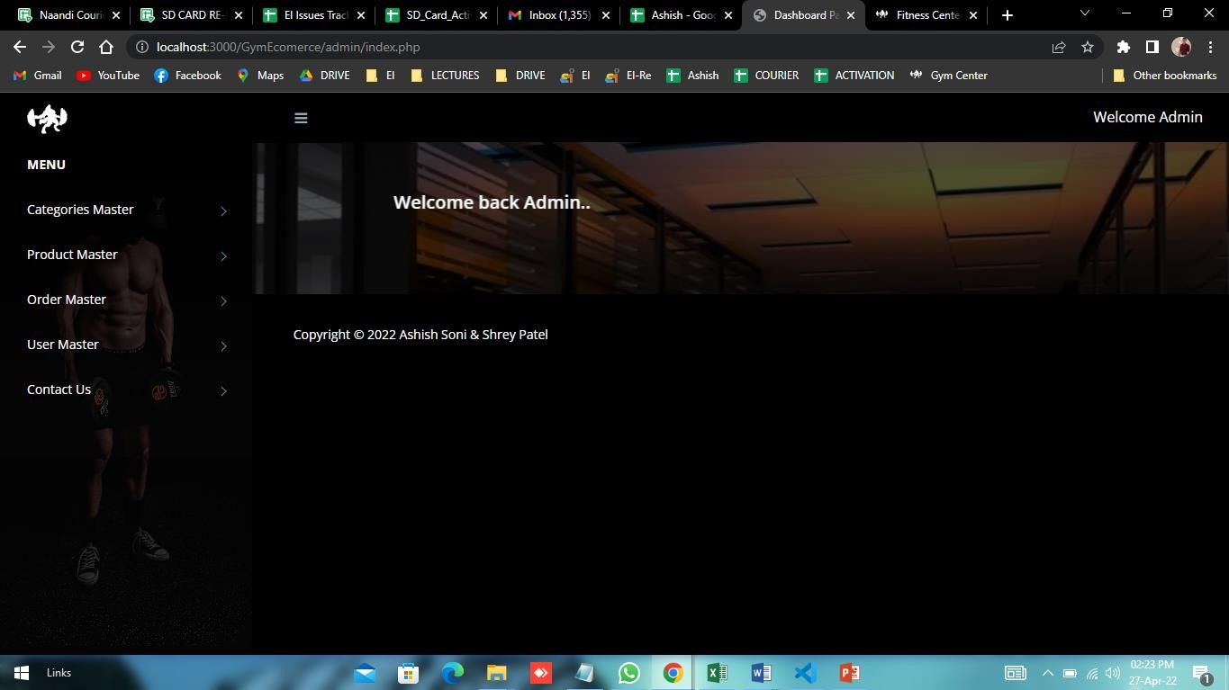

**Admin Home Page: -** This is the admin home page**.**

P a g e 20 | 53

**Fitness Center**

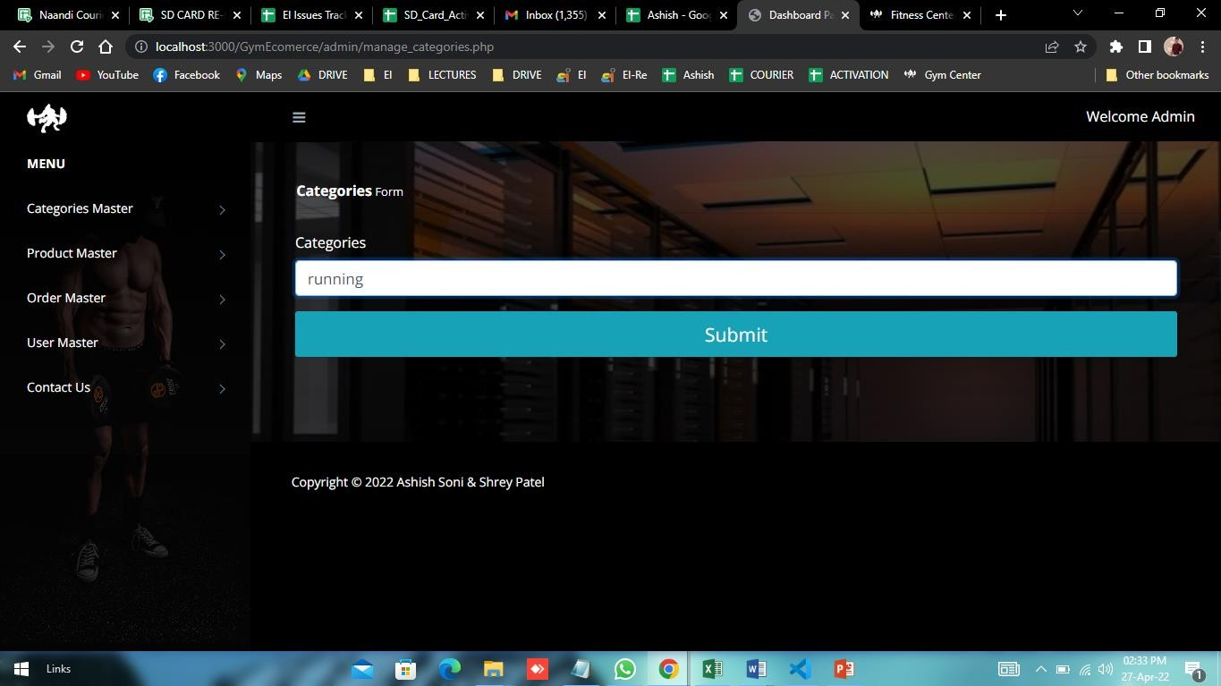

**Categories**

**Add Categories Page:-**here admin can add many categories.

P a g e 21 | 53

**Fitness Center**

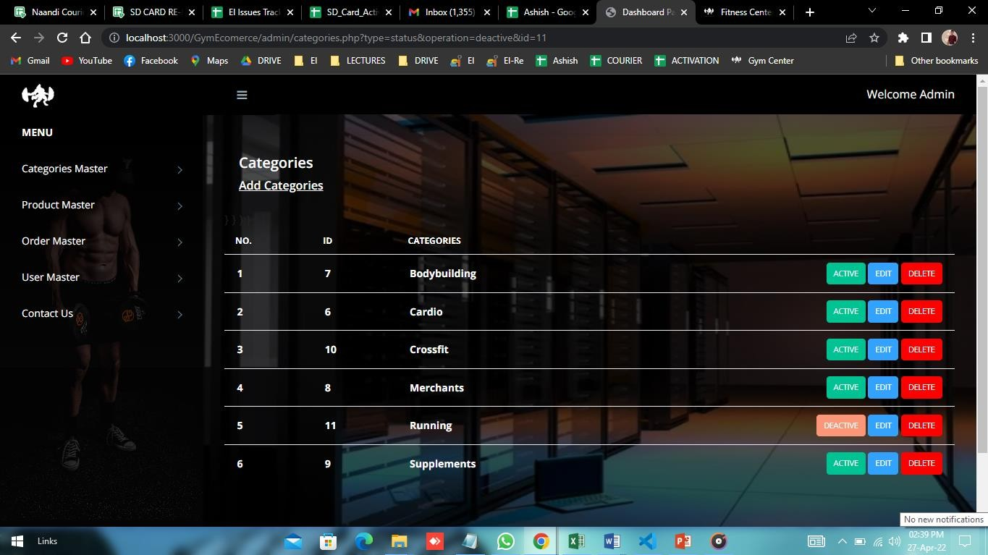

**Categories Page: -** Here admin can change categories like deactive, active, edit, delete.

P a g e 22 | 53

**Fitness Center**

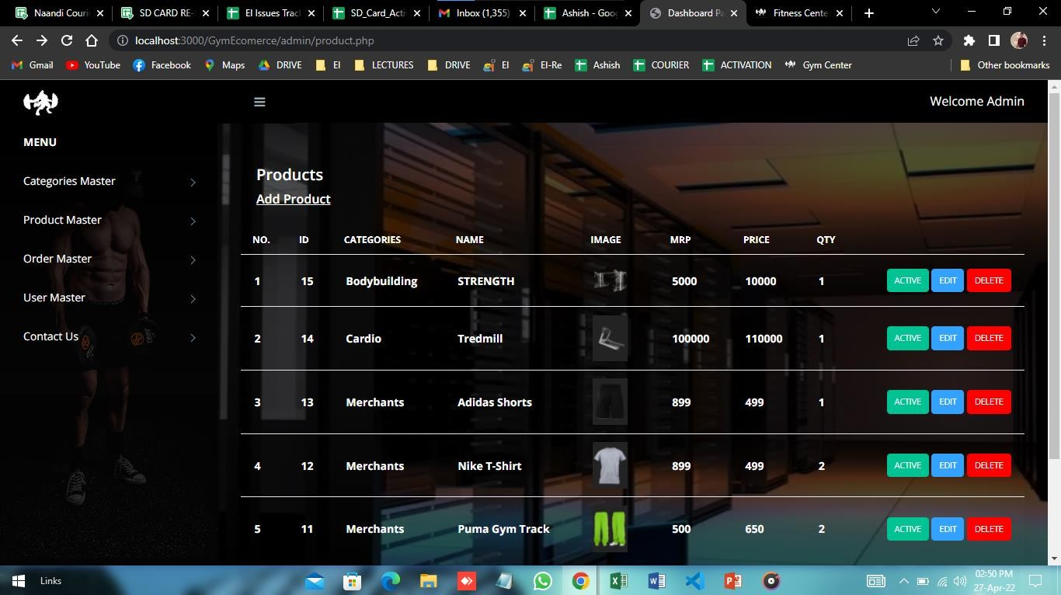

### Product

**Product Page: -** Admin can add the product, delete, edit & deactive.

P a g e 23 | 53

**Fitness Center**

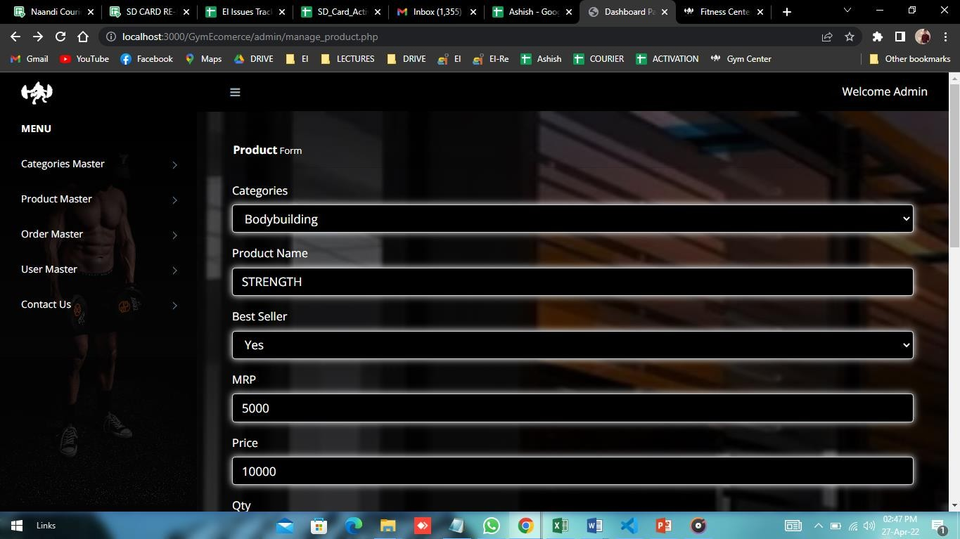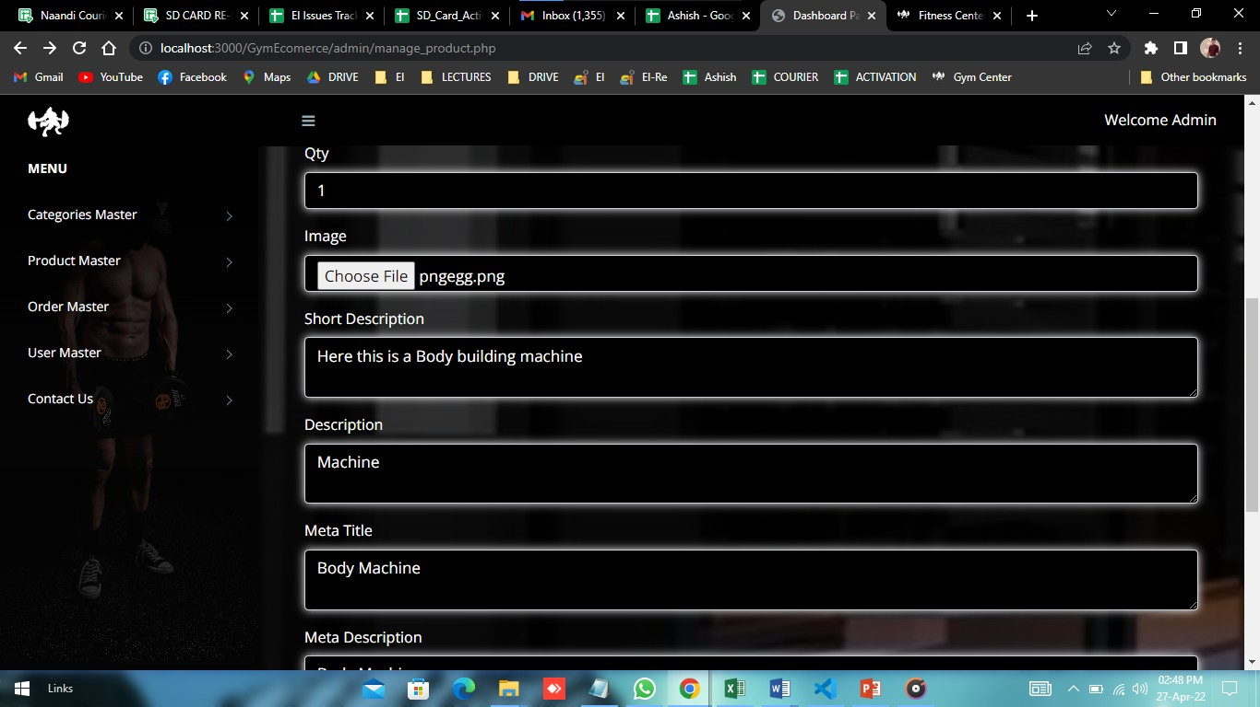

Add Product Process...

P a g e 24 | 53

**Fitness Center**

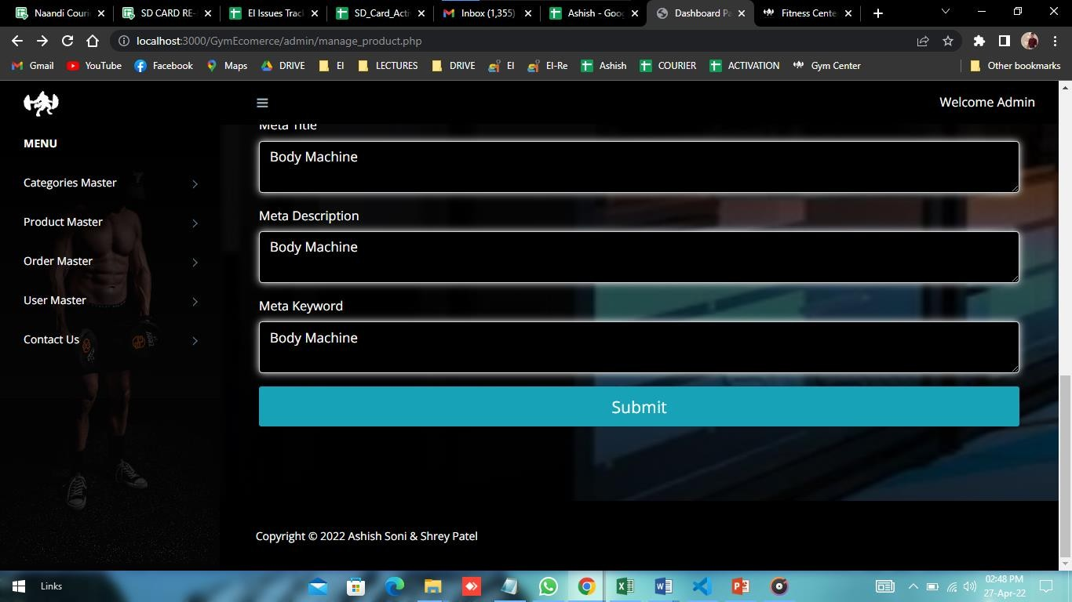

P a g e 25 | 53

**Fitness Center**

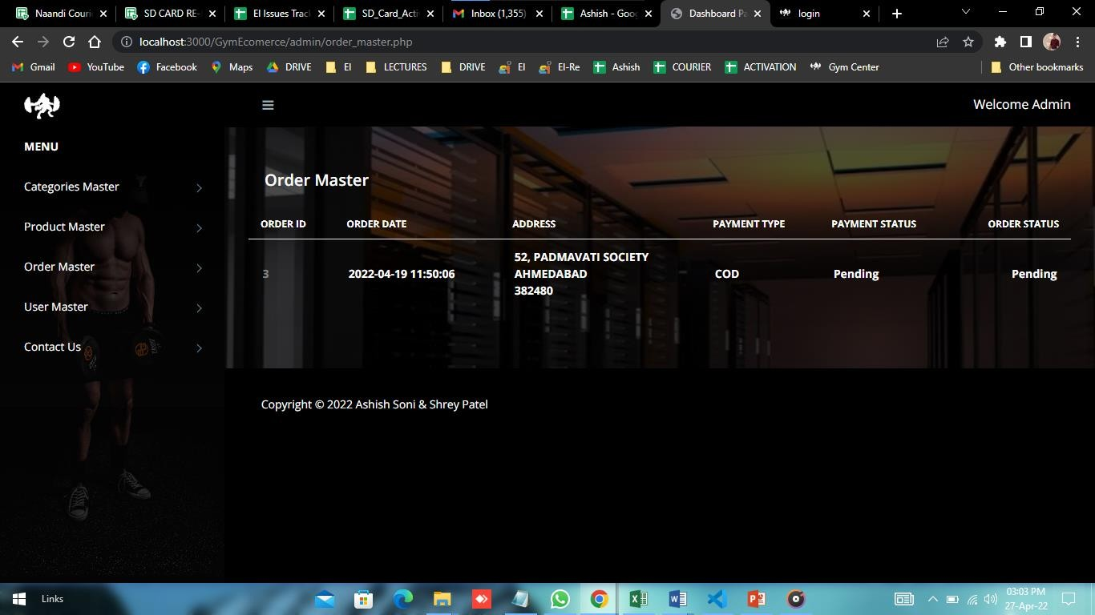

### Order

**Order Page:** - Here admin can view the pending orders.

P a g e 26 | 53

**Fitness Center**

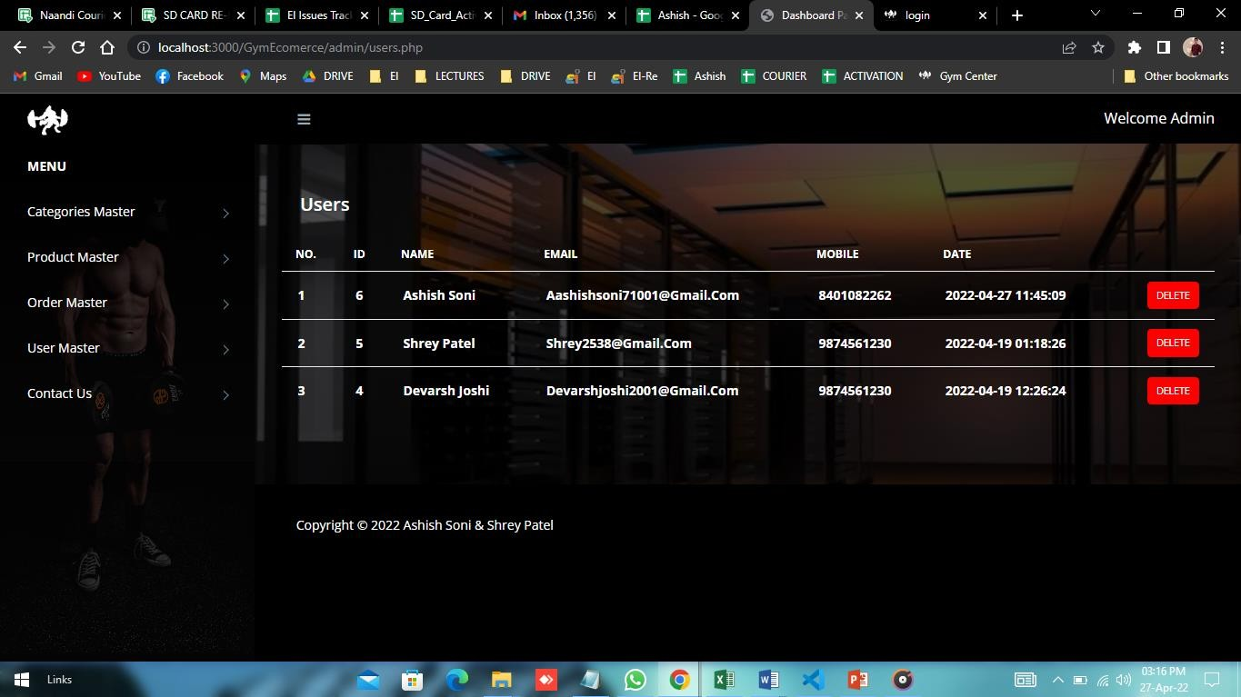

### User

**User Page: -** Here admin can view and delete users.

P a g e 27 | 53

**Fitness Center**

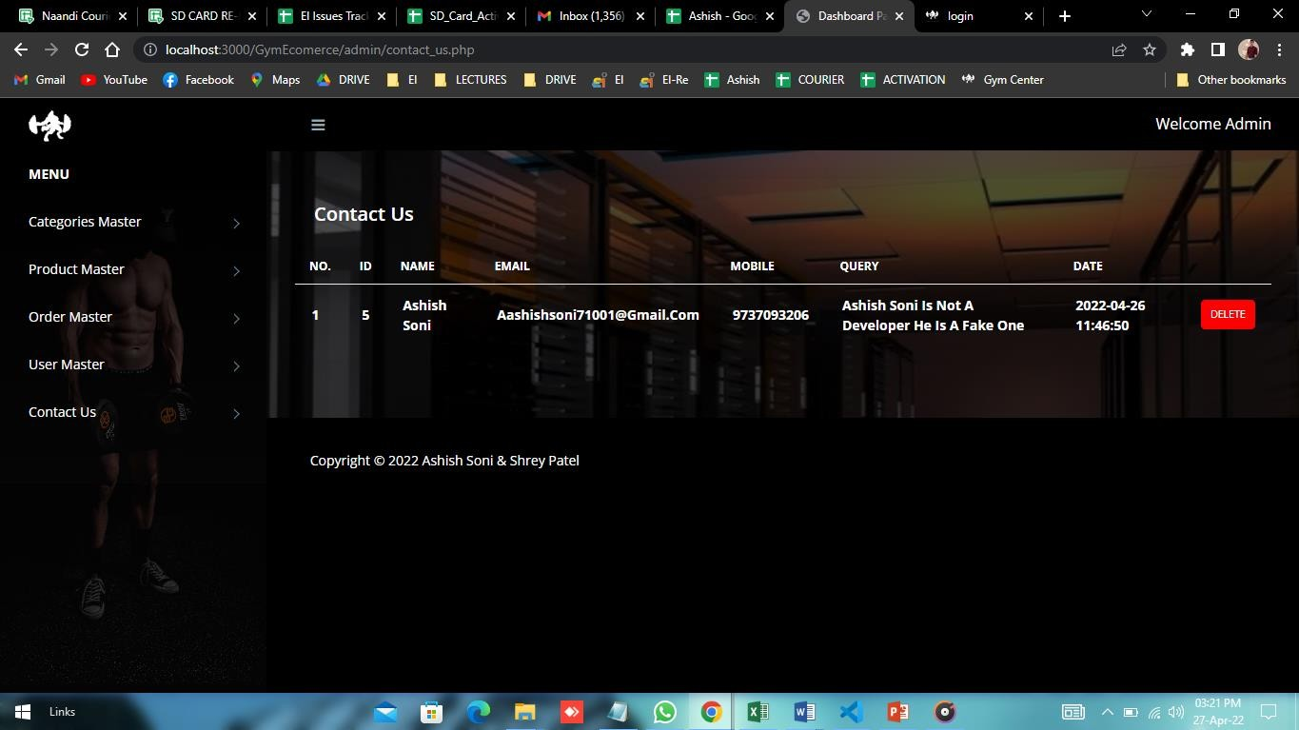

### Contact us

**Contact us page: -** Here admin can view the query from user.

P a g e 28 | 53

**Fitness Center**

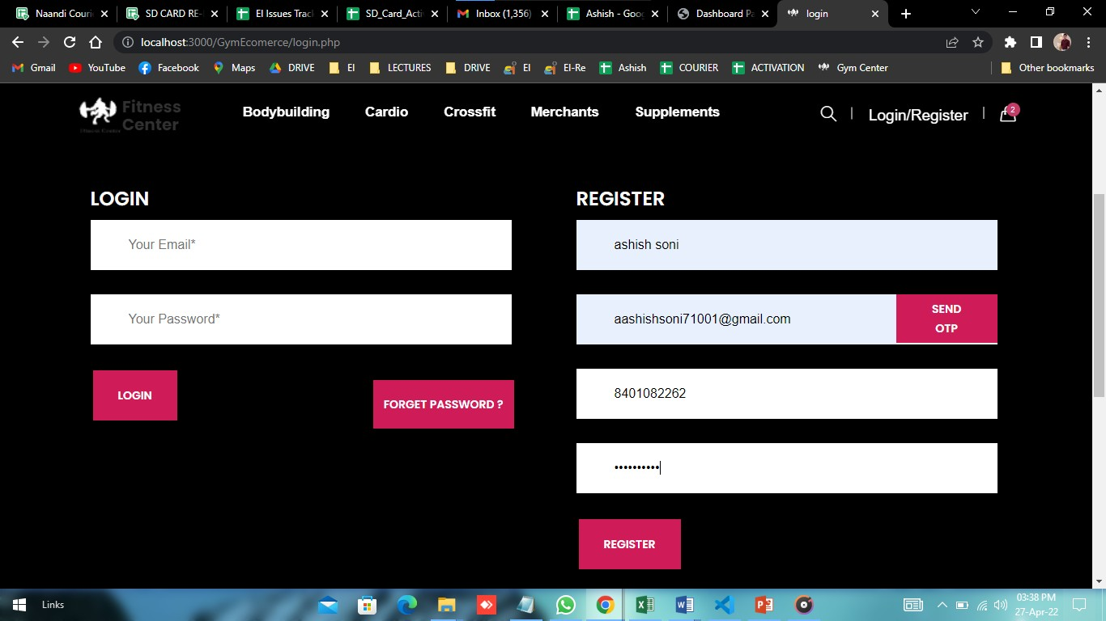

## User Side

1. **User Registration: -** user can register with the name, email id, mobile number & password.

P a g e 29 | 53

**Fitness Center**

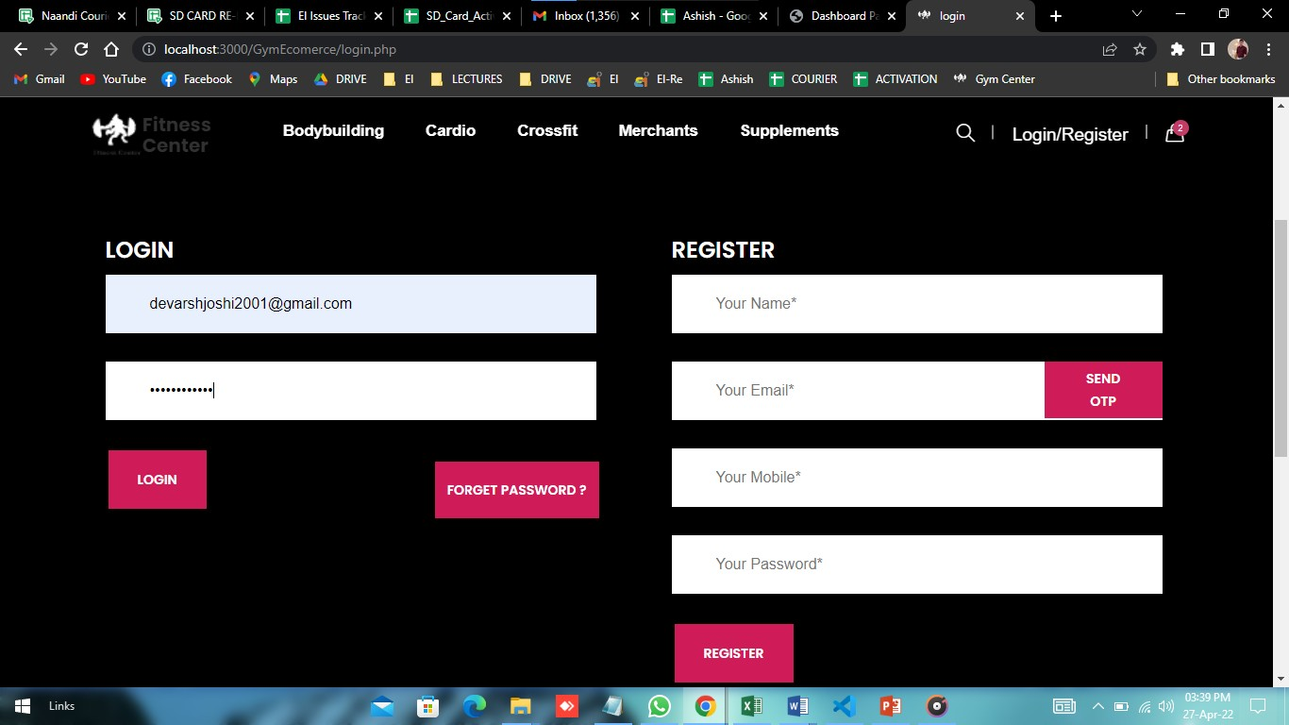

1. **Login page: -** user can login with the email id and password.

P a g e 30 | 53

**Fitness Center**

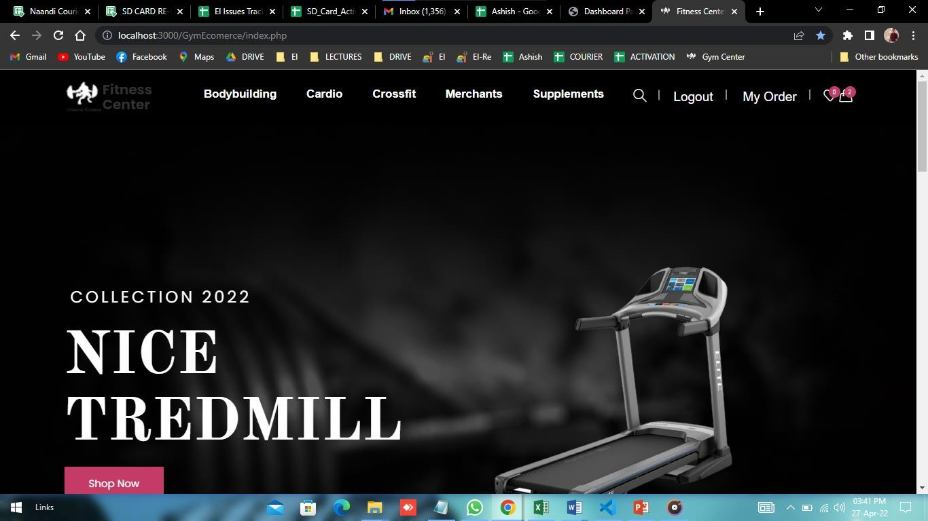

1. **Home Page:-**After log in home page like this.

P a g e 31 | 53

**Fitness Center**

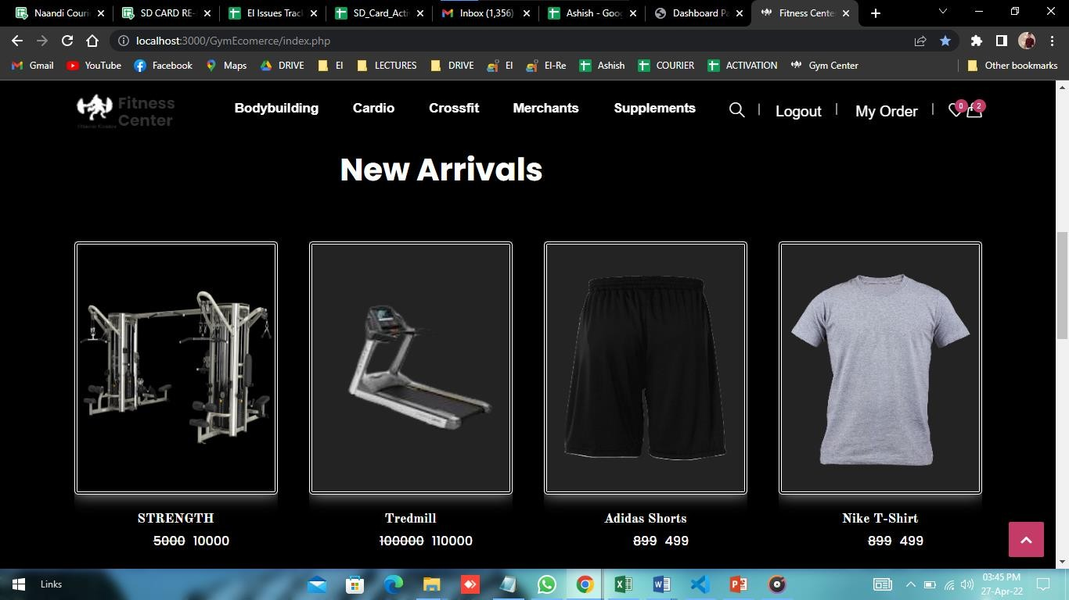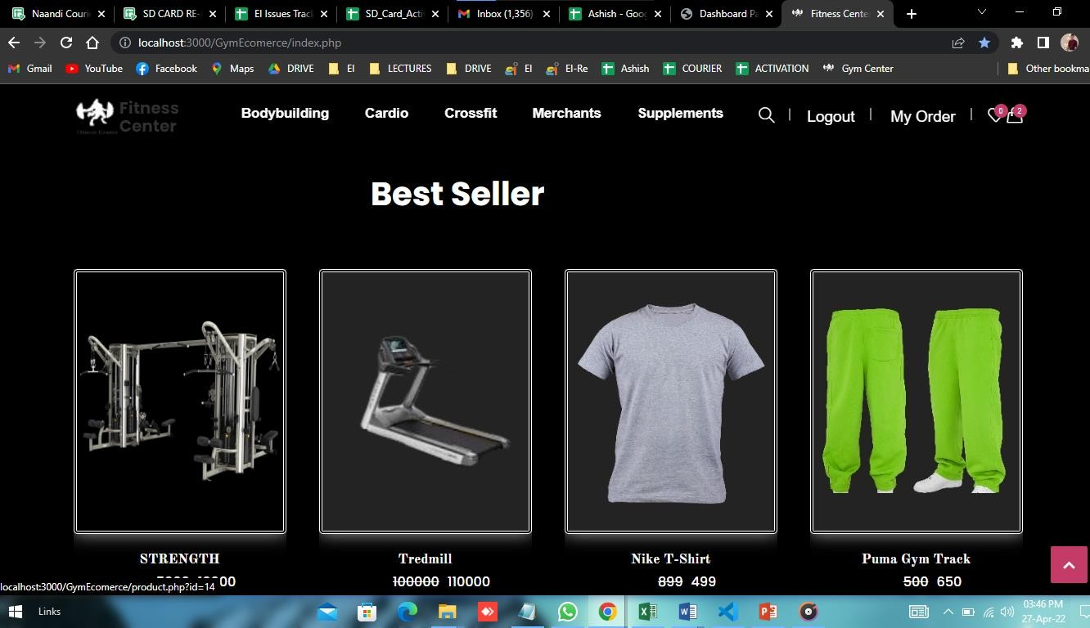

1. **Product: -** Here some product for New arrivals, Best Seller.
   * **Best Seller**

P a g e 32 | 53

**Fitness Center**

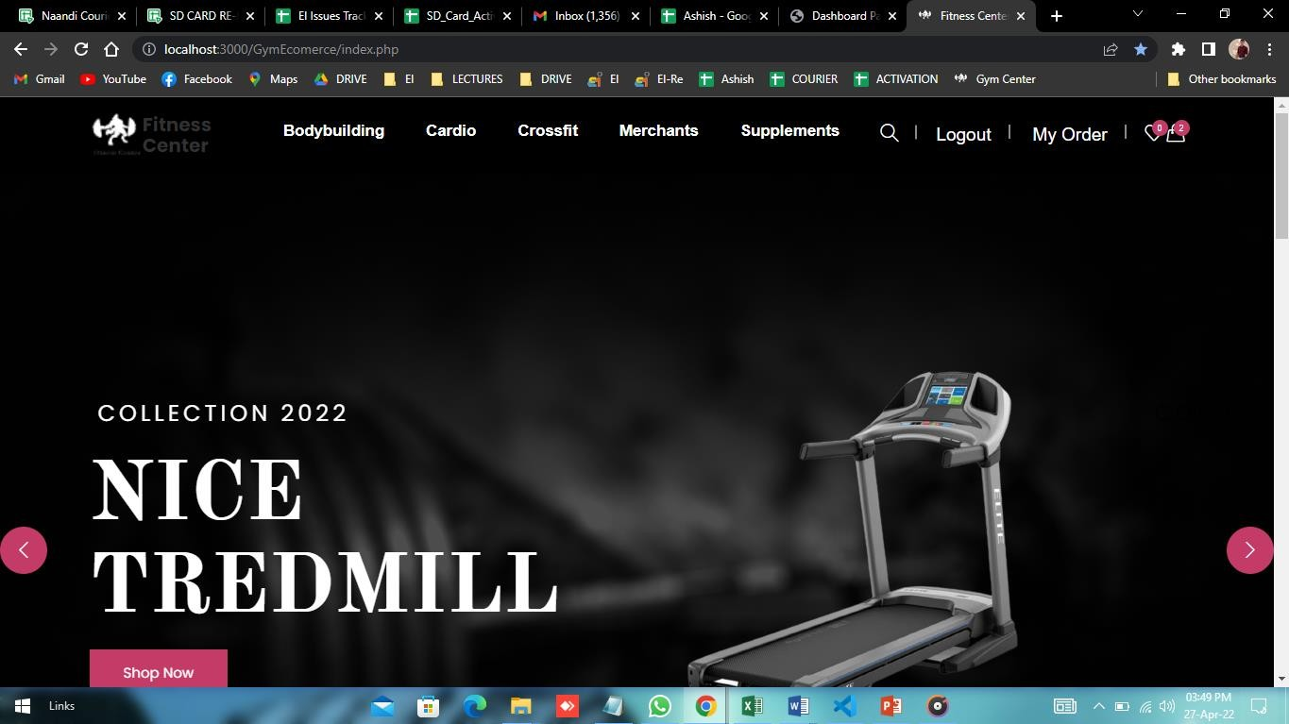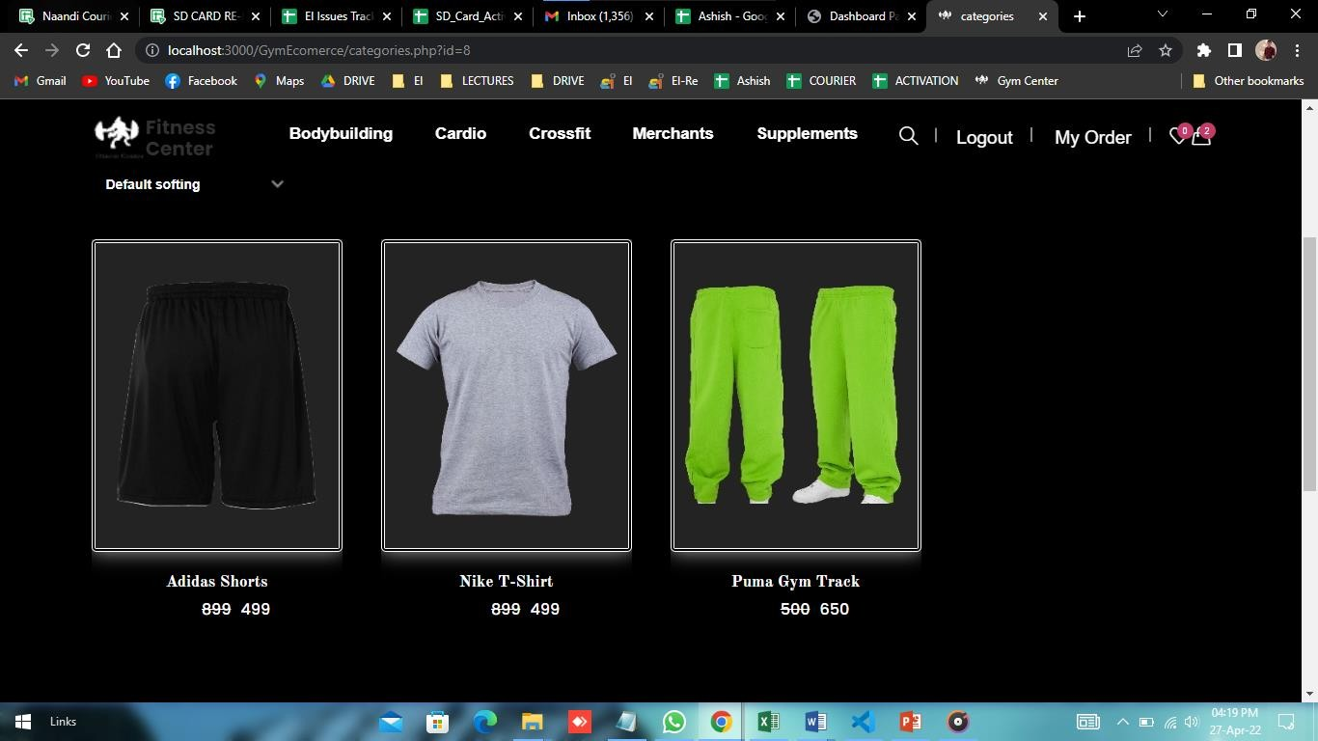

1. **Category: -** Here User can buy any product then select any categories if he/she wants.
   * **After Select Cardio category**

P a g e 33 | 53

**Fitness Center**

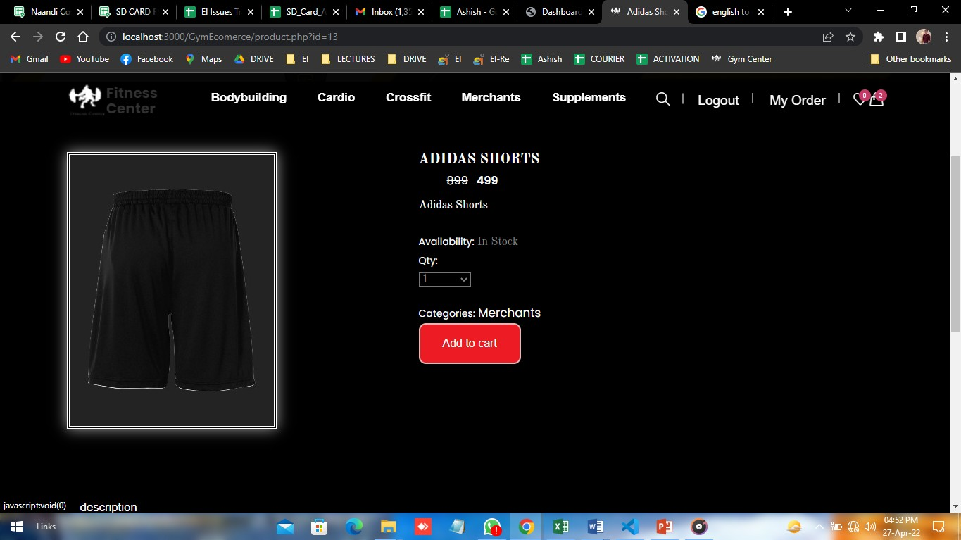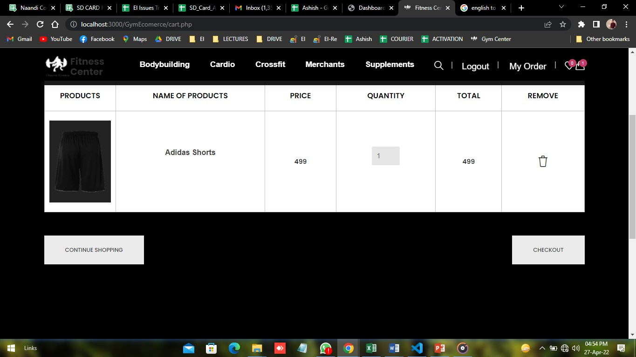

**Buy Product: -** Here User can also can do add to cart and buy

* + **After Add to cart User can show this page.**

P a g e 34 | 53

**Fitness Center**

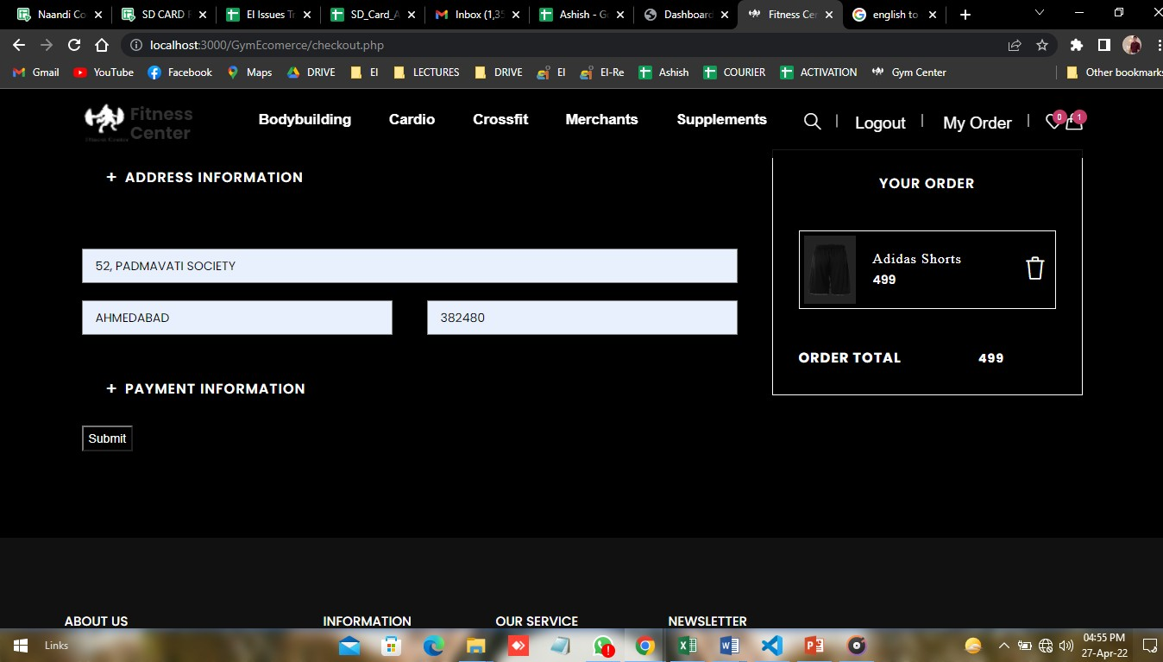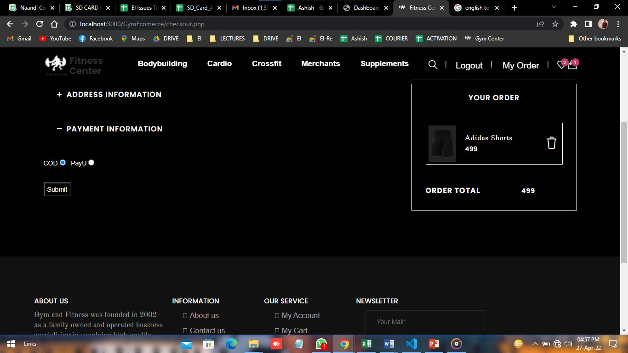

* + Here User if he/she want to buy product then click on checkout button.
  + After Click on checkout button the page like this,
  + User can add address details & Payment details.

**Address Details:-**

**Payment Details:-**

P a g e 35 | 53

**Fitness Center**

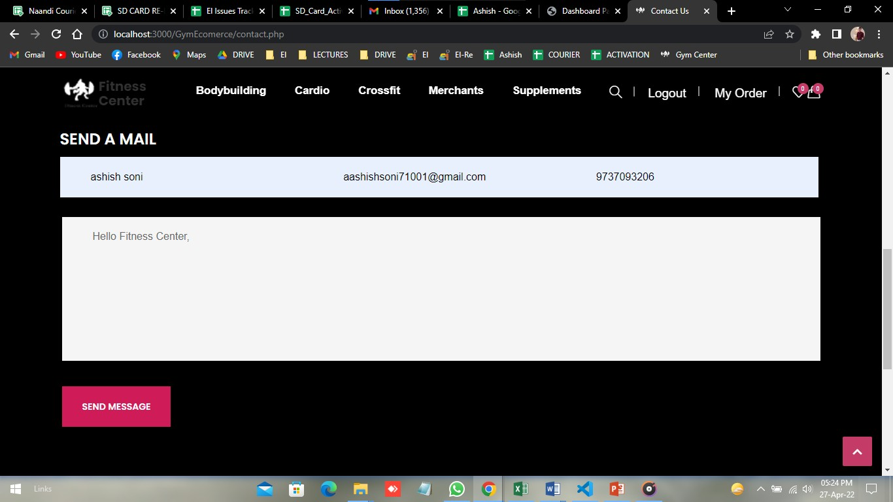

**Contact us Page:-**If user have any query then user can contact us.

P a g e 36 | 53

**Fitness Center**

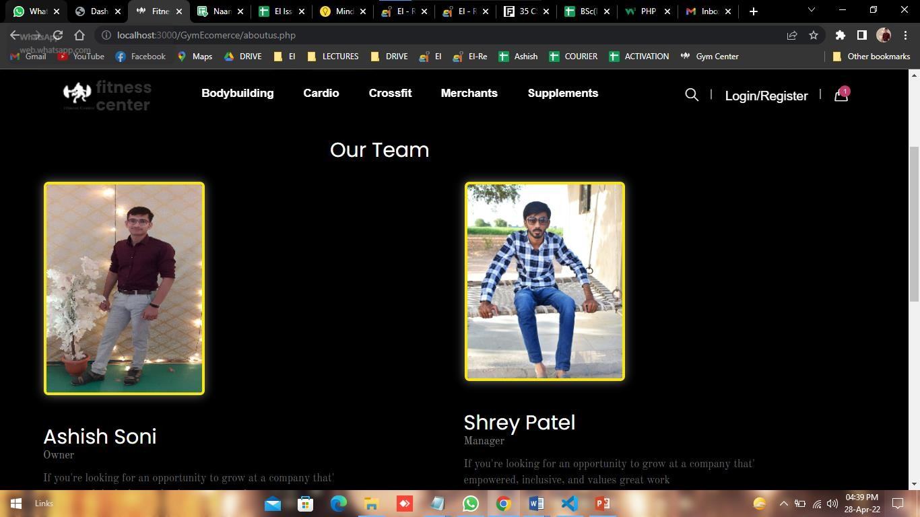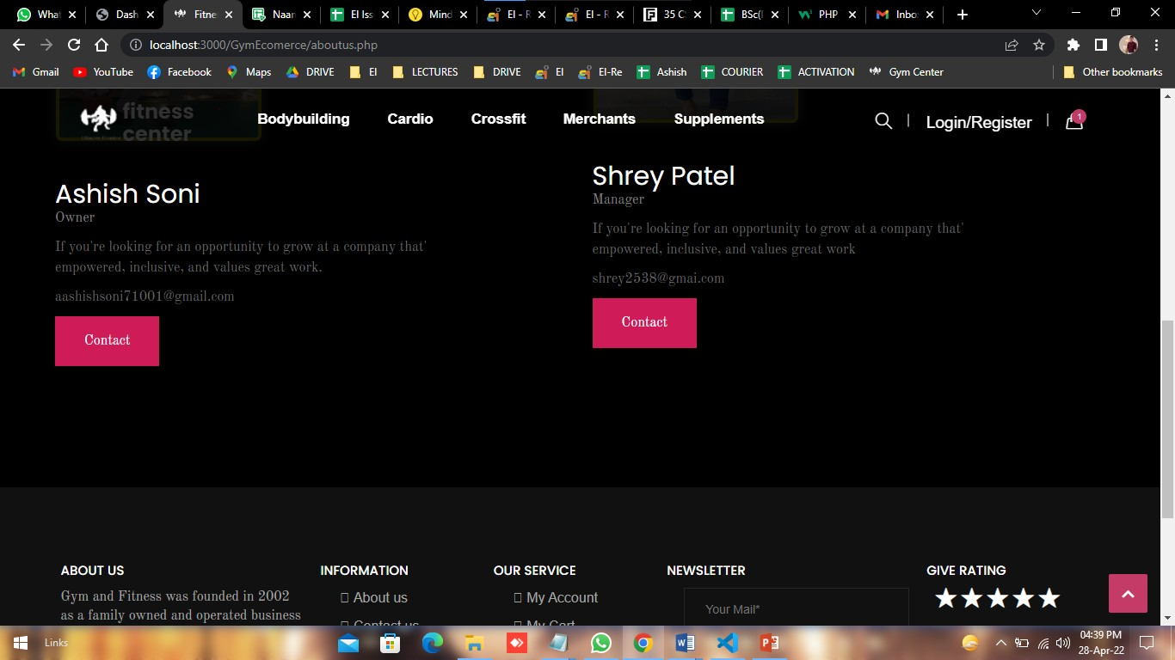

**About us page: -** User can get all details and review related to Our website.

P a g e 37 | 53

**Fitness Center**

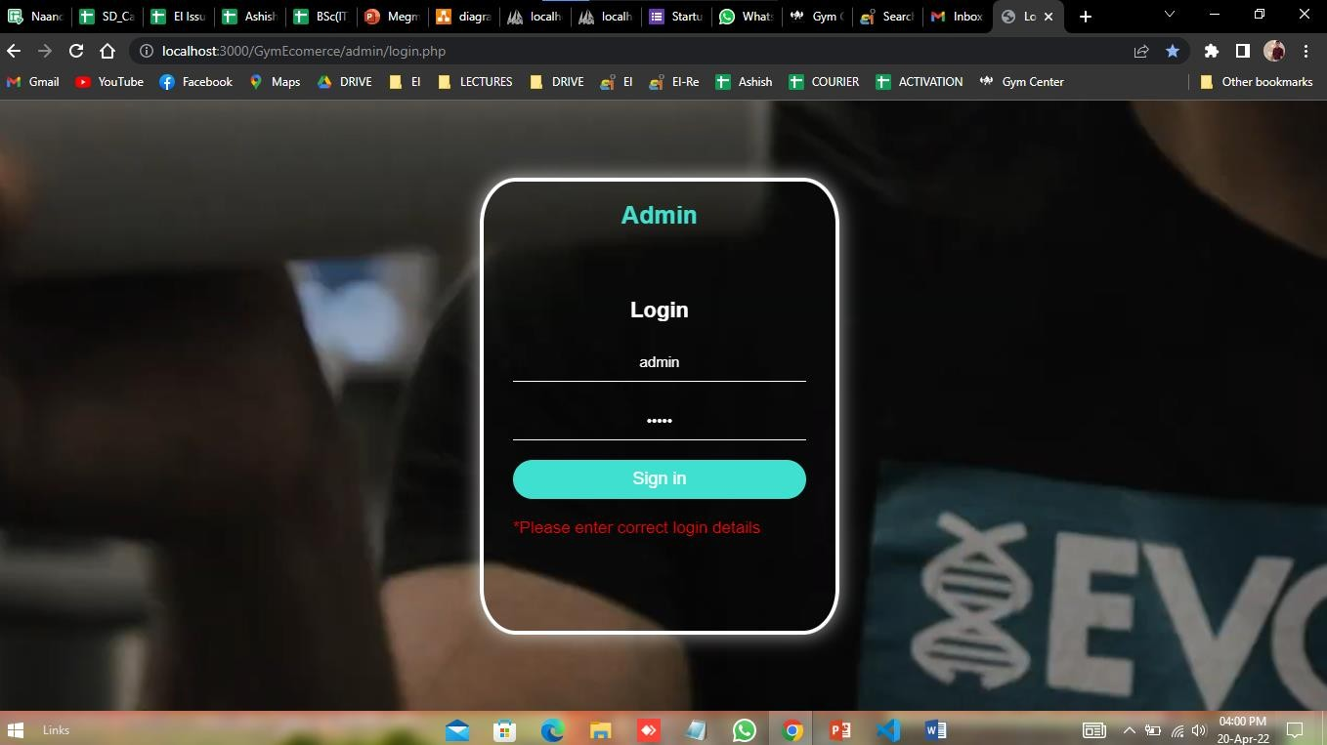

# Output Design

## Admin side

**Admin Log in: -** Is admin can enter invalid details.

P a g e 38 | 53

**Fitness Center**



**Categories add: -** Admin add running category.

P a g e 39 | 53

**Fitness Center**



**Product add: -** Add product successfully.

P a g e 40 | 53

**Fitness Center**

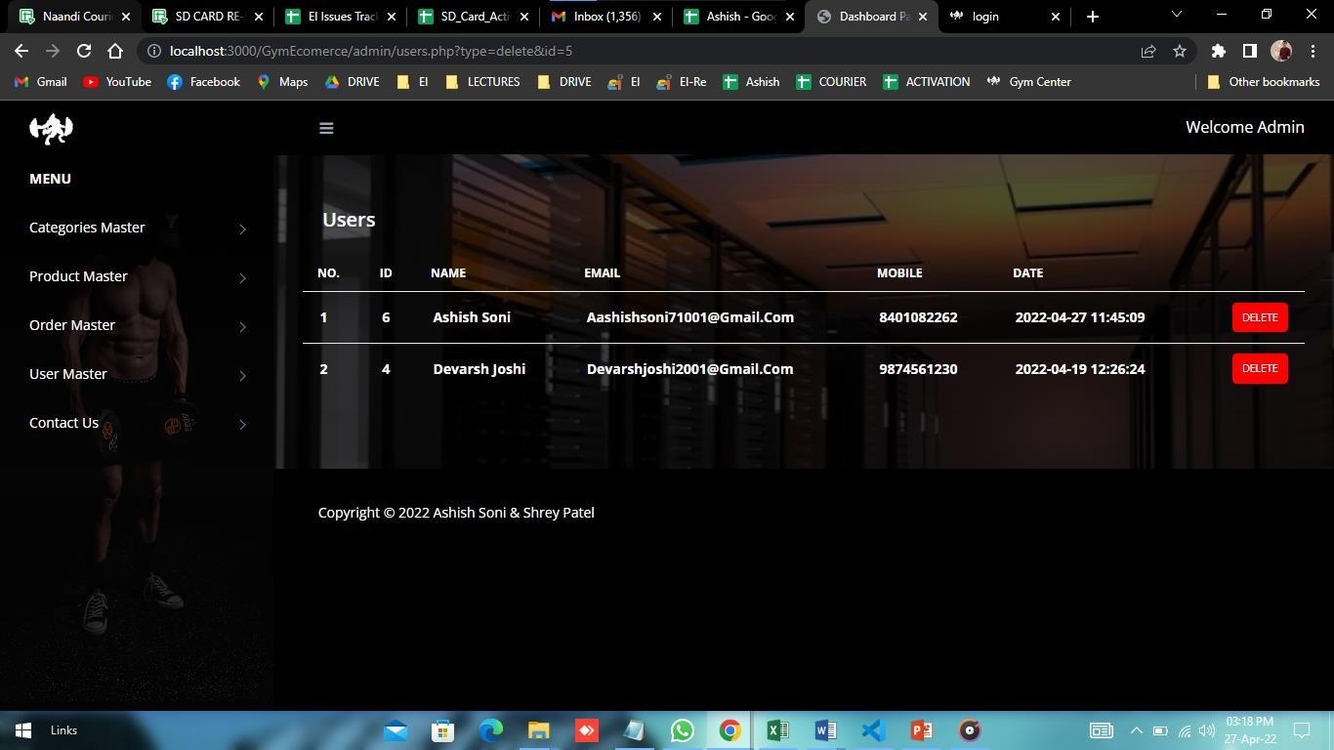

**User: -** Here User delete by admin.

P a g e 41 | 53

**Fitness Center**

**User Query:-**

**Contact us response**

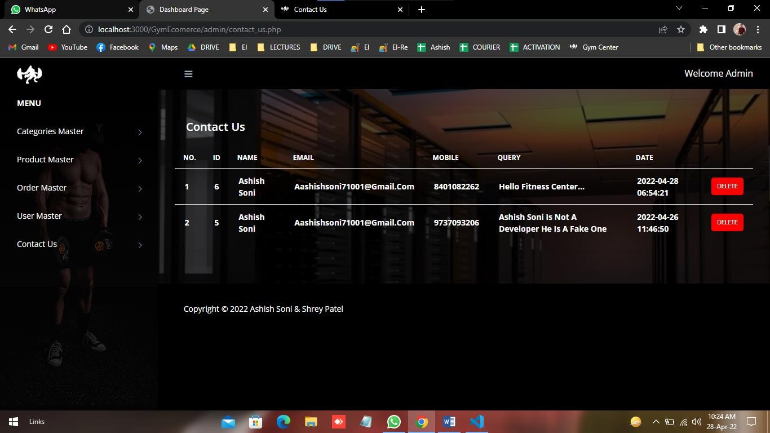

**Admin View**

P a g e 42 | 53

## User Side

**Fitness Center**

**Register page: -** After add correct details then message shown like this,

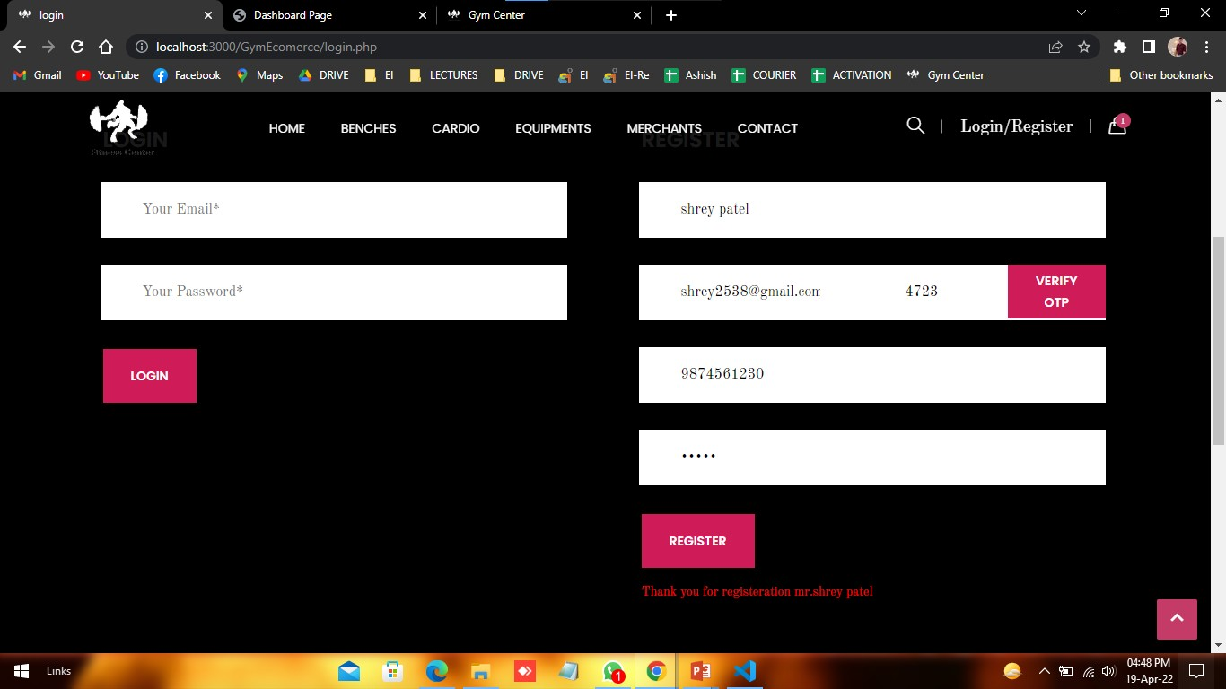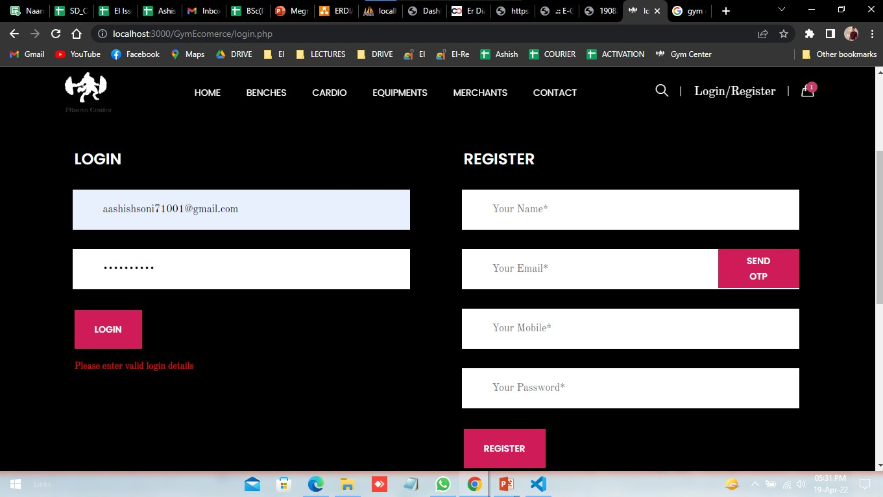

**Login: -** After add wrong details in login then message shown like this,

P a g e 43 | 53

**Fitness Center**

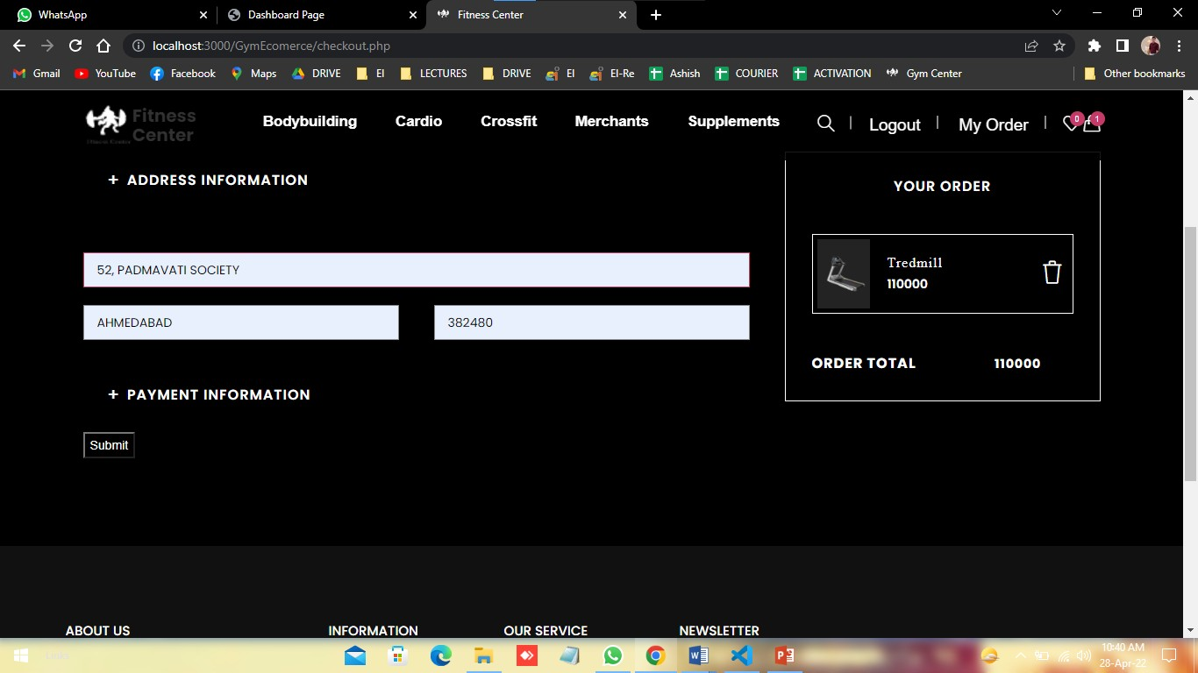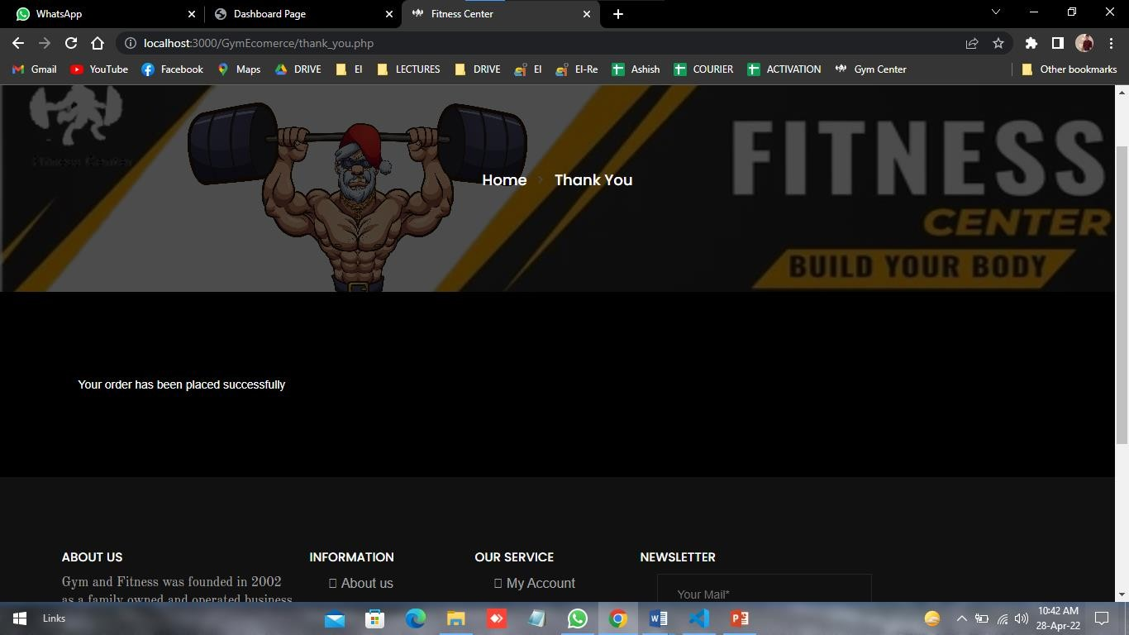

**Checkout page: -** User can add product into add to cart after she/he want to checkout he must need to login, after log in page like this.

After add address and payment details click on submit button.

P a g e 44 | 53

**Fitness Center**

# TESTING

#### Test case 1:-

|  |  |
| --- | --- |
| **Test Case Id** | B002 |
| **Purpose** | User Registration |
| **Test case created by** | Ashish |
| **Test Environment** | Google Chrome |
| **Prerequisites** | Enter name Email  Mobile number password |
| **Test Procedure** | Enter name, Email etc. |
| **Test data** | Email-id |
| **Expected Result** | If Email-id is existing than give error message |
| **Actual Result** | Thank you for registration Mr. shrey patel |
| **Verdict :Pass/Fail** | pass |
| **Comment** | Registration For buy any product |

P a g e 45 | 53

**Fitness Center**



#### Output...

P a g e 46 | 53

**Fitness Center**

#### Test case 2:

|  |  |
| --- | --- |
| **Test Case Id** | B003 |
| **Purpose** | User Login |
| **Test case created by** | Ashish |
| **Test Environment** | Google Chrome |
| **Prerequisites** | Email Password |
| **Test Procedure** | Enter Email , Password |
| **Test data** | Email-id |
| **Expected Result** | If Password is wrong than give error message |
| **Actual Result** | Login Successful |
| **Verdict :Pass/Fail** | Fail |
| **Comment** | Login to make order, transection , Track Order |

P a g e 47 | 53

**Fitness Center**



**Output…**

P a g e 48 | 53

**Fitness Center**

#### Test Case 3

|  |  |
| --- | --- |
| **Test Case Id** | B004 |
| **Purpose** | Admin Login |
| **Test case created by** | Ashish |
| **Test Environment** | Google Chrome |
| **Prerequisites** | username Password |
| **Test Procedure** | Enter username , Password |
| **Test data** | Username |
| **Expected Result** | If Username, Password is wrong than give error message |
| **Actual Result** | Login Successful |
| **Verdict :Pass/Fail** | pass |
| **Comment** | Login to make manage order, product etc. |

P a g e 49 | 53

**Fitness Center**

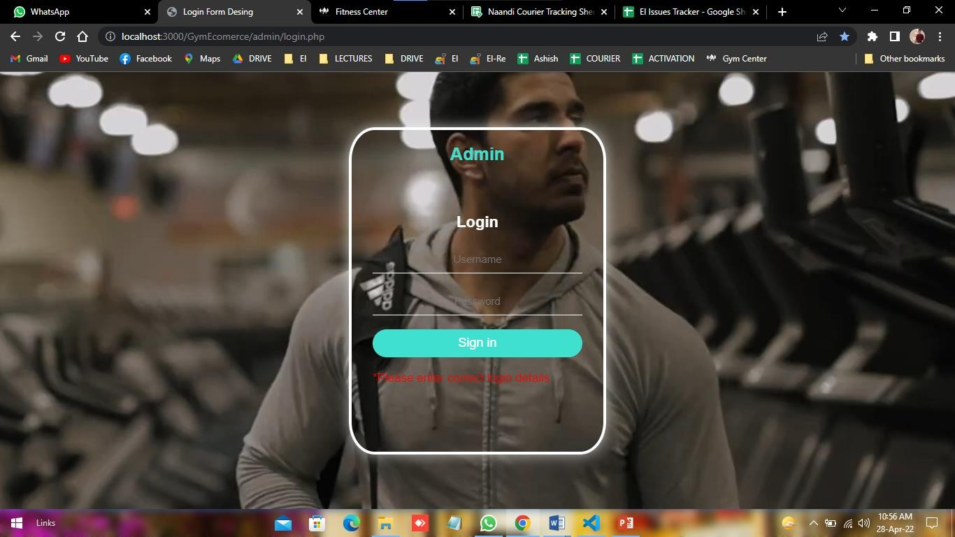

**Output…**

P a g e 50 | 53

**Fitness Center**

# FUTURE ENHANCEMENT

* Fitness Center project aimed with the help of technology, the fitness industry is absolutely booming. And the thing is – it’s not slowing down anytime soon. Gyms, fitness services, and nutrition manufacturers are all catering to this evolution in interesting and exciting new ways.

**Some are the expansion which we have thought of are:-**

* Add Different payment method such as COD, PAYTM and UPI.
* Allow Customer to customize order.

P a g e 51 | 53

**Fitness Center**

# CONCLUSION

* The Project will help users to Engaging in regular physical activity may produce improvements in an individual's physical health, cognitive performance, and psychological well-being.
* The increasing opportunities to user to make order and according the product and user can find any product & make order. It will save user time.
* User can see all product and order.

P a g e 52 | 53

**Fitness Center**

# BIBLIOGRAPHY/REFERENCES:-

#### Book:-

|  |  |  |  |
| --- | --- | --- | --- |
| **No** | **Book Title** | **Author** | **Publisher** |
| 1 | Headfirst PHP & MYSQL | Michael Morrison | Hardie Grant Publishing |

**Web References**: -

* + During the development of our system, we have taken the reference from various sites, which we would like to mention in this section.
* [**https://www.w3schools.com/php**](https://www.w3schools.com/php)
* [**https://www.tutorialspoint.com/php/index.html**](https://www.tutorialspoint.com/php/index.html)
* [**https://www.javatpoint.com/php-tutorial**](https://www.javatpoint.com/php-tutorial)
* [**https://youtube.com**](https://youtube.com/)

P a g e 53 | 53